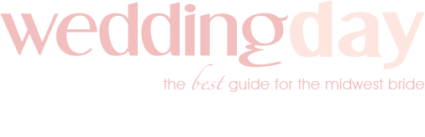

Engagement Session Questionnaire

By completing the following form, I _______________________________, authorize WeddingDay Magazine to contact my vendors and use the photos and story from my engagement for publication in an upcoming blog and/or digital issue, on weddingday-online.com, on the WeddingDay social media pages and for any future features on the WeddingDay platform.
Engagement Date: ____________________ Couple’s Names:_________________________________________
Couple’s Instagram Handles: __________________________________________________________________________

How did you and your S.O. meet?

How did he/she propose?

Let’s talk about that ring! Did your partner choose it themselves or did you help pick it out? Describe the style
and what you love most about it!

How did you choose your engagement session photographer?

How did you select the locale for your engagement session?

How did you choose your outfit(s) for your engagement session?

Did you know what you wanted in your wedding when you got engaged? Or are you still figuring it out?

How is your wedding planning experience going so far?

